1. Enter below United HealthCare link in Chrome browser

<https://connect.werally.com/state-plan-selection/uhc.medicaid/state>

1. Select and click the state as per available in provider address in excel For Example: NJ – New Jersey; **if provider state is not available in list at website, we need not to proceed further**

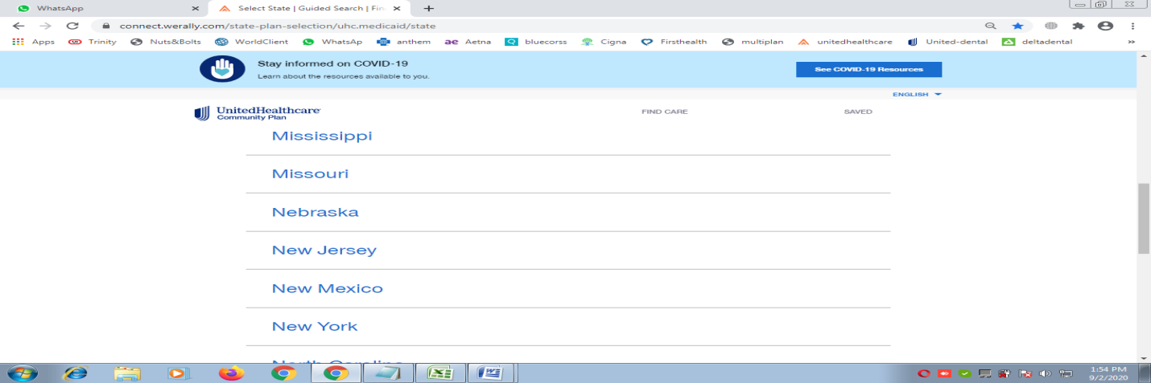

3) After clicking on State, always select **first option** from next window if it

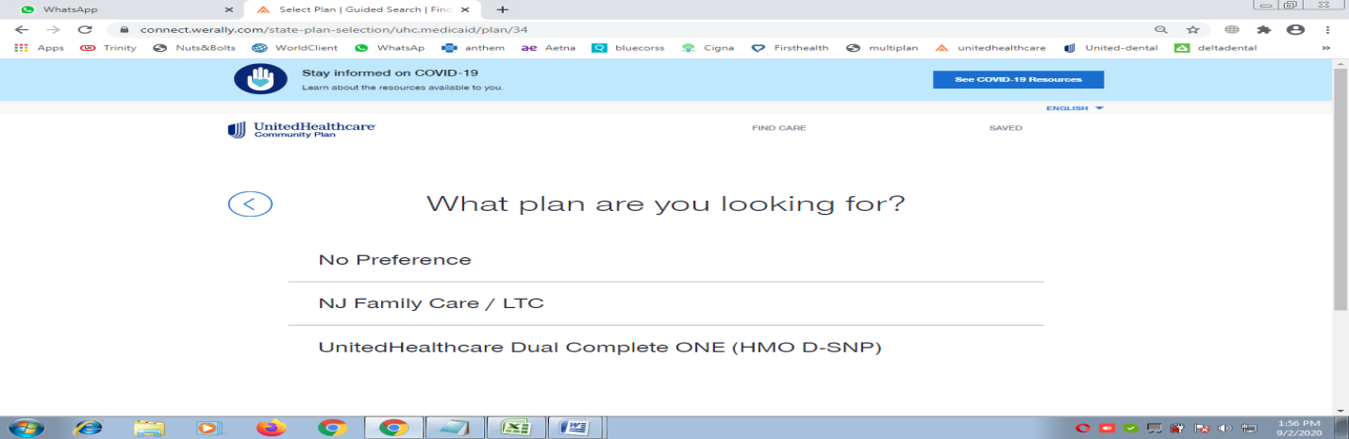

4) Then next window will open and we have to enter Zipcode and then pick correct location from dropdown and press **continue**

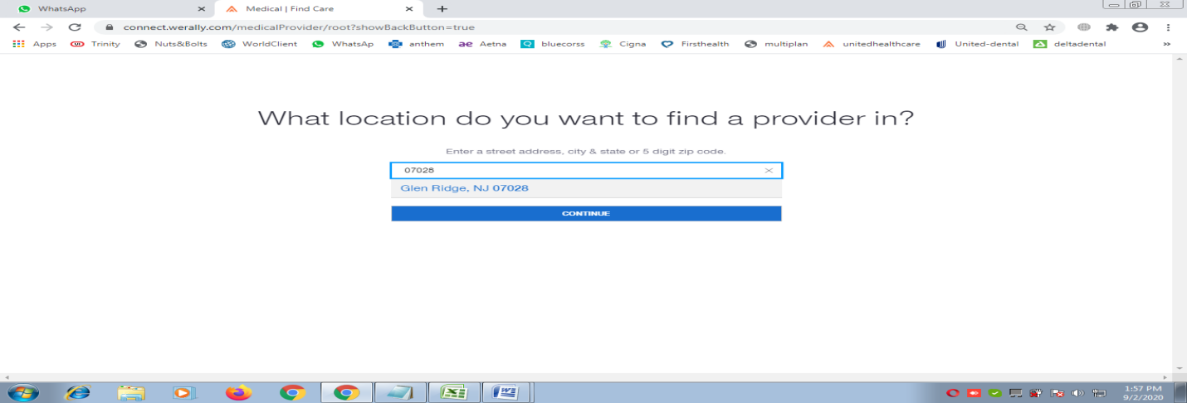

5) In next window, Enter Lastname, Firstname and pick correct name from the list and press search

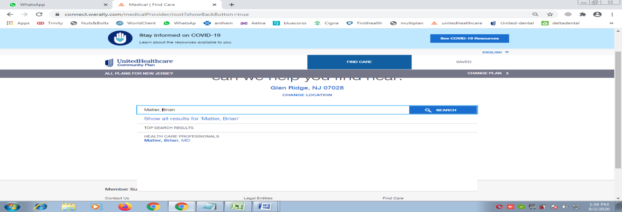

6) Next Provider list would open and we have to Click on **Accepted Plans**

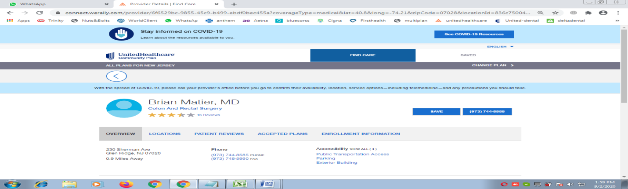

7) Pick all the plans appearing in grey color Band and put in excel in ‘S’ column in following format

**UnitedHealthCare: Plan1 | UnitedHealthCare: Plan2 | UnitedHealthCare: Plan3 etc**

